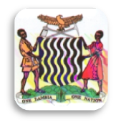
CHAMA DAY SECONDARY SCHOOL
NATURAL SCIENCES DEPARTMENT
GRADE 9B ENVIRONMENTAL SCIENCE ORIENTATION QUIZ 1 TERM 1
Wednesday, 29 January 2014
ANSWER ALL THE QUESTIONS DURATION: 20 Minutes MARKS: 10
- Draw an electric circuit diagram showing a battery (4 cells), an open switch and a light bulb. Label your diagram with appropriate electric symbols. [2]
- 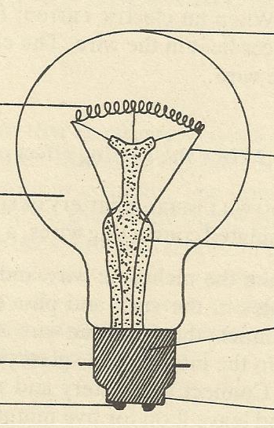Study the diagram below showing an electric light bulb designed and presented by a Grade 9B pupil for JETS Projects' exhibitions.
S

T

U

Oxygen

V

X
W
Y Z
- Label the parts S and T. [2]
- What is the function of part V? [1]
- What is wrong with this design by a 9B pupil? [1]
- How can you correct the mistake identified in (c)? [1]
- The insulating material used to fill part Z is made of which material? [1]
- Which is a better electric light bulb, the one whose filament is made of nichrome wire, iron, steel wool or tungsten? Give a reason for your answer [2]
Total = 10 marks

"SCIENCE IS LIFE, RUN FOR IT," Eng. Chomba

